Implementing Predictive Analytics to Optimize Customer Churn Prediction
Activity 2: Data Quality Check & Preprocessing Plan
1.Check for missing values, duplicates, and inconsistencies:
Objective:
The objective of this step is to assess the quality of the Telco Churn dataset by identifying missing values, duplicate records, and any inconsistencies that may affect further analysis and predictive modeling.
Steps Performed
- The dataset was loaded into a Python environment using the Pandas library.
- Basic dataset inspection was performed to understand the structure, number of rows and columns, and data types of each feature.
- Missing values were identified by checking null values across all columns.
- Duplicate records were examined to ensure that each customer record is unique.
- Categorical variables were reviewed to identify inconsistent values such as incorrect labels, extra spaces, or unexpected categories.
Observations and Data Issues Identified
- No missing values were detected across any columns in the dataset.
- Duplicate records were checked, and none were found, ensuring that each customer is uniquely represented.
- Categorical variables were reviewed for inconsistencies such as unexpected values or formatting issues, and the dataset was found to be consistent and well-structured.
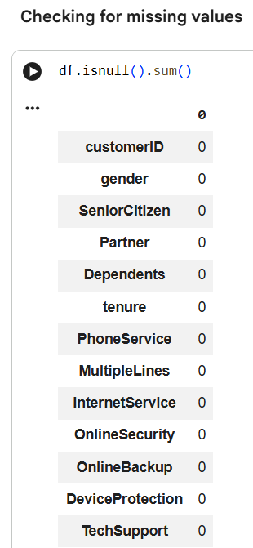
2. Identify Categorical and Numerical Variables:
Objective:
The objective of this step is to identify and categorize the dataset features into categorical and numerical variables to support effective data preprocessing and model development.
Approach
The dataset was analyzed using Python to identify the data type of each column. Columns with integer and floating-point data types were classified as numerical variables, while columns with object data types were classified as categorical variables.
Findings
- Numerical Variables (3):
  - SeniorCitizen
  - tenure
  - MonthlyCharges
These variables represent quantitative information related to customer demographics, service duration, and billing amounts.
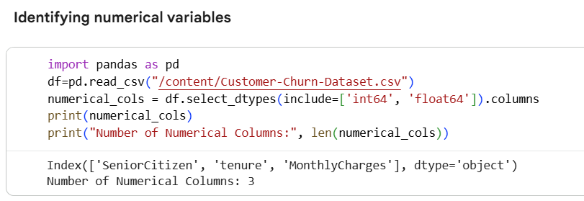
- Categorical Variables (18):
  - customerID
  - gender
  - Partner
  - Dependents
  - PhoneService
  - MultipleLines
  - InternetService
  - OnlineSecurity
  - OnlineBackup
  - DeviceProtection
  - TechSupport
  - StreamingTV
  - StreamingMovies
  - Contract
  - PaperlessBilling
  - PaymentMethod
  - TotalCharges
  - Churn
These variables describe customer characteristics, service subscriptions, billing preferences, and churn status.
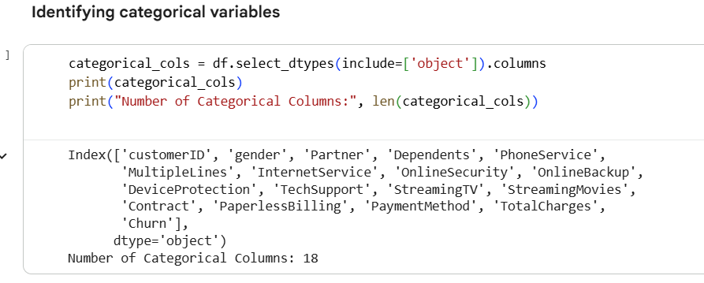

3. Plan data preprocessing strategy (encoding, normalization, handling nulls).
Objective
The objective of this step is to define an appropriate data preprocessing strategy to prepare the Telco Churn dataset for analysis and predictive modeling. This includes handling null values, encoding categorical variables, and normalizing numerical features.
i)Encoding
Encoding Categorical Variables Machine learning models require numerical input. Therefore, categorical variables were converted into numerical representations using appropriate encoding techniques.
Binary Categorical Encoding (Label Encoding)
Columns containing only two categories (Yes/No) were converted into numerical values:
- Yes → 1
- No → 0
The following columns were label encoded:
- Partner
- Dependents
- PhoneService
- PaperlessBilling
- OnlineSecurity
- OnlineBackup
- DeviceProtection
- TechSupport
- StreamingTV
- StreamingMovies
- MultipleLines
This encoding preserves simplicity while retaining meaningful information.
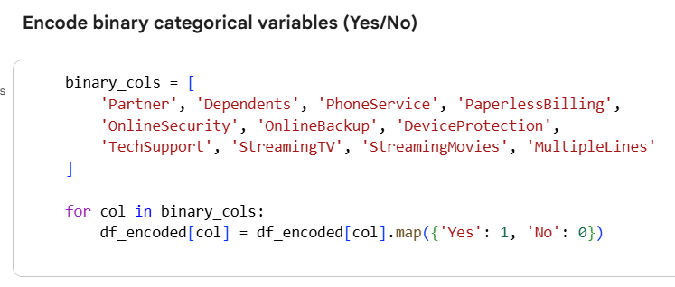
Encoding Multi-Category Variables (One-Hot Encoding)
Columns with more than two categories were encoded using One-Hot Encoding:
- gender
- Contract
- PaymentMethod
- InternetService
One-hot encoding creates separate binary columns for each category.
To avoid multicollinearity, the drop_first=True parameter was used. This means:
- One category is treated as a reference (baseline)
- The dropped category is implicitly represented when all encoded columns are zero
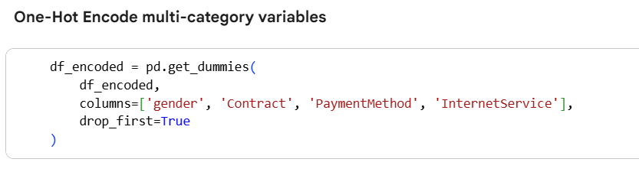
Example: Contract Column
Original categories:
- Month-to-month
- One year
- Two year
Encoded columns:
- Contract_One year
- Contract_Two year
Interpretation:
- If both columns are False, the contract type is Month-to-month
- If Contract_One year = True, the contract is One year
- If Contract_Two year = True, the contract is Two year
No information is lost in this process.
Encoding the Target Variable The target variable Churn was converted into numerical format to enable predictive modeling:

- Yes → 1
- No → 0
This allows the model to learn patterns associated with customer churn.
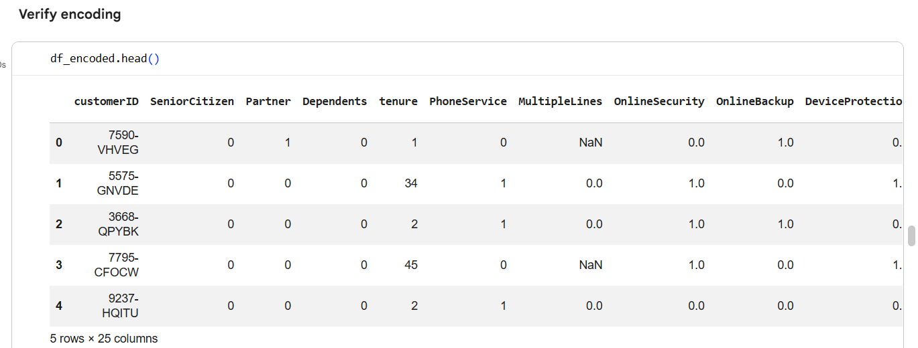
Data Type Correction – TotalCharges Column
After encoding the categorical variables, a data type verification was performed to ensure all features were in a format suitable for machine learning models.
Issue Identified
- The TotalCharges column was stored as an object (string) data type instead of a numerical type.
- This occurred due to formatting issues in the dataset, such as empty strings or non-numeric values.
- Machine learning models cannot process numerical values stored as text.
Action Taken
- The TotalCharges column was converted from object to float using numeric type conversion.
- Any invalid or non-numeric values were coerced into missing values during conversion.
- These missing values were then handled appropriately during the missing value treatment step.
Reason for Data Type Conversion
- TotalCharges represents a continuous numerical value (billing amount).
- Converting it to float ensures:
  - Accurate mathematical calculations
  - Proper scaling during normalization
  - Compatibility with machine learning algorithms
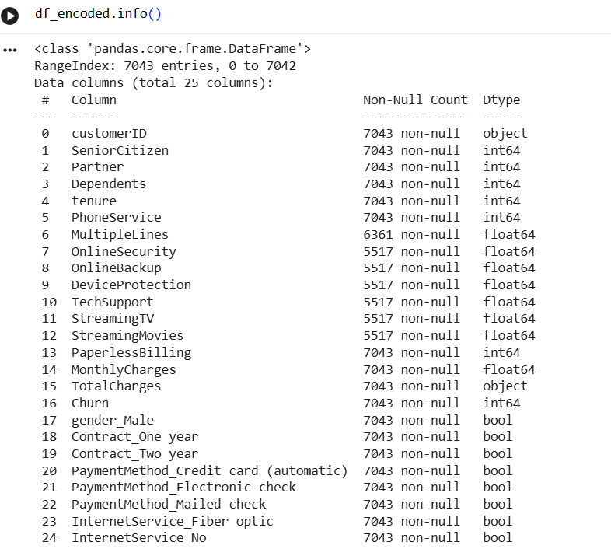
Converting Total Charges Column into Float Datatype
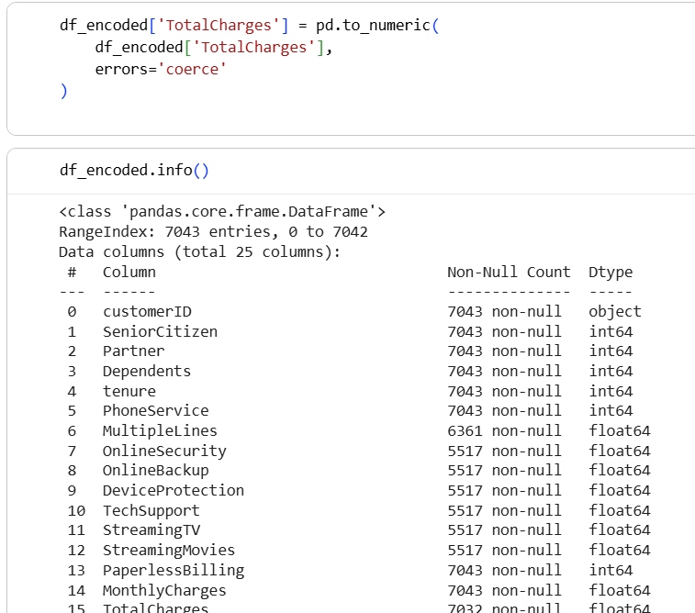

ii) Handling Missing (Null) Values
STEP 1: Identify columns with missing values
First, always check where nulls exist.
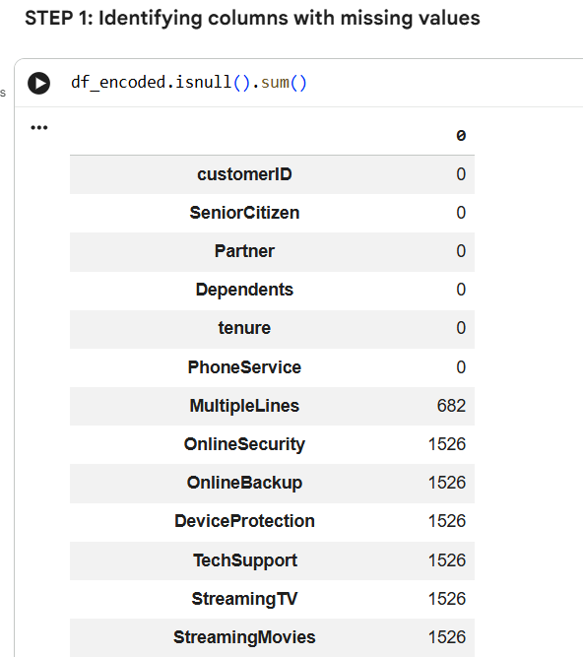
STEP 2: Understanding the nature of each column
Before filling nulls, ask:
What does this column represent?
STEP 3: Handle service-related binary columns (Yes/No → 1/0)
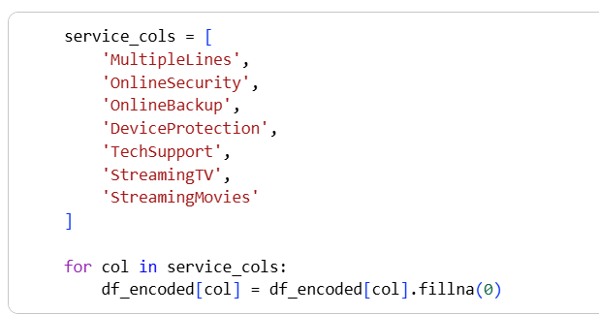
STEP 4: Handle numerical continuous column – TotalCharges
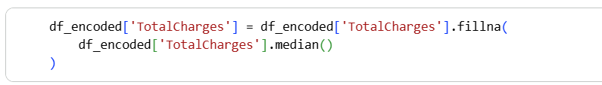
STEP 5: Verify missing values are handled
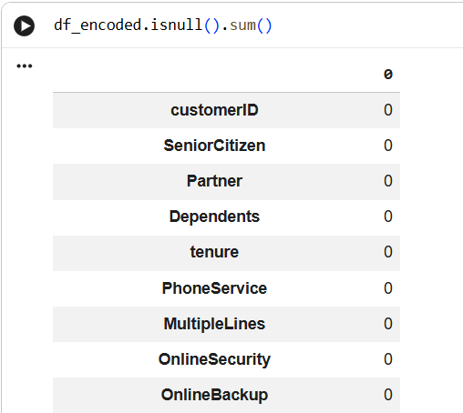
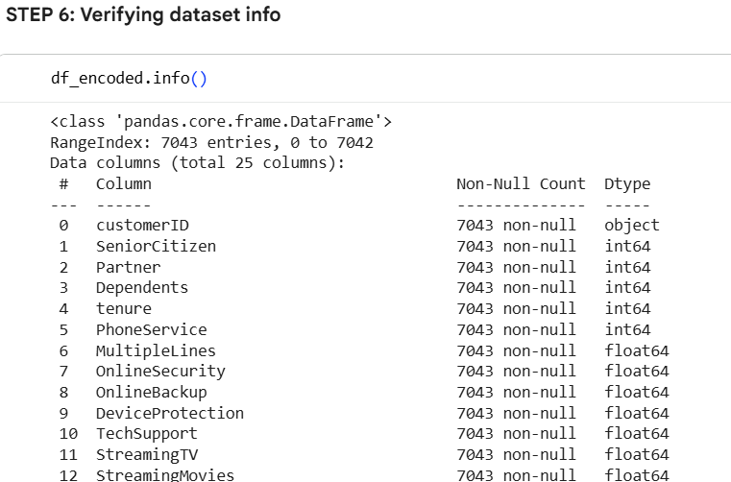

Missing values were handled based on the nature of each feature.
Service-related columns represent whether a customer has subscribed to specific services. Missing values in these columns indicate the absence of the service and were therefore replaced with 0.
For the continuous numerical variable TotalCharges, missing values were imputed using the median. Using zero would misrepresent customer payment behavior, whereas median imputation preserves the overall distribution of the data and avoids bias.
iii)Normalization
Normalization is a data preprocessing technique used to scale numerical features so that they fall within a similar range. In many datasets, different numerical variables may have very different value ranges. When such data is used directly, machine learning models may give more importance to features with larger numerical values, even if they are not more meaningful.
Why Normalization is Needed
Machine learning algorithms rely on mathematical calculations such as distance measurement and gradient optimization. If one feature has much larger values than others, it can dominate the learning process and negatively affect model performance. Normalization helps ensure that each feature contributes equally to the model.

Simple Example
Consider two numerical features in a customer dataset:
Feature | Example Values
tenure | 1 – 72
TotalCharges | 100 – 9000
If normalization is not applied:
- TotalCharges values are much larger than tenure
- The model may incorrectly assume TotalCharges is more important
After normalization:
- Both features are scaled to a similar range (e.g., 0 to 1)
- The model learns patterns more effectively and fairly
- Common Normalization Technique
- One commonly used normalization method is Min-Max Scaling, which transforms values using the formula:
- $\text{Normalized Value}=\frac{\left(x − \text{min}\right)}{\left(\text{max} − \text{min}\right)}$
- This method scales all values to a range between 0 and 1.
Normalization was applied to continuous numerical features to ensure that all variables contribute equally to the predictive model. Since machine learning algorithms are sensitive to feature scale, numerical columns with larger ranges can disproportionately influence model performance.
The following numerical columns were normalized using Min-Max Scaling:
- tenure
- MonthlyCharges
- TotalCharges
Min-Max normalization scales values to a range between 0 and 1, improving model stability and convergence. Binary and one-hot encoded features were excluded from normalization, as they already exist on a comparable scale.
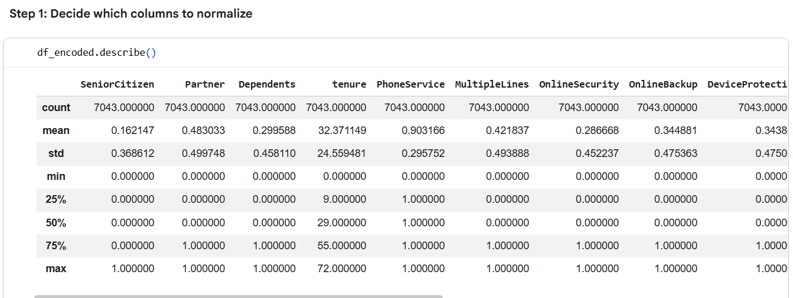
Based on the describe() output, tenure, MonthlyCharges, and TotalCharges were selected for normalization because they have larger and varying value ranges (higher max values), unlike binary encoded features which are already on a comparable 0–1 scale.
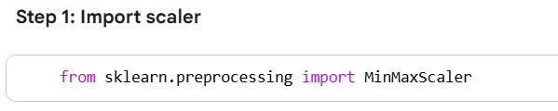
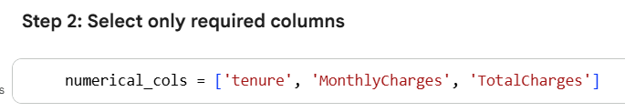
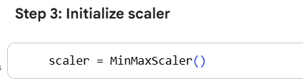
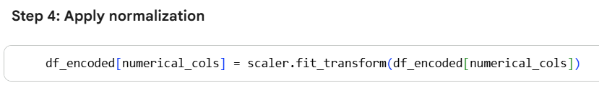
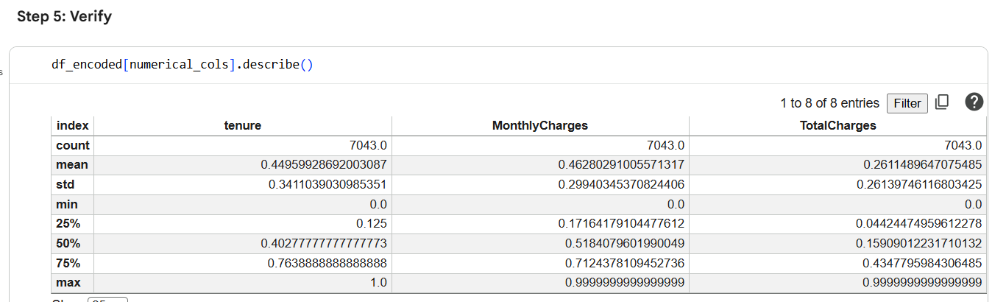
Based on the describe() output, tenure, MonthlyCharges, and TotalCharges were selected for normalization because they have larger and varying value ranges (higher max values), unlike binary encoded features which are already on a comparable 0–1 scale.

